Programming I  Diploma in CSF / IT / FI / CICTP  Year 1 (2019/2020) Semester 1 | Week 1
 | 20 minutes
Installing Python

OBJECTIVES

At the end of this exercise, all students should have:
- installed the Python programming language

- RESOURCES

Your first resource is Python.Org (www.python.org).

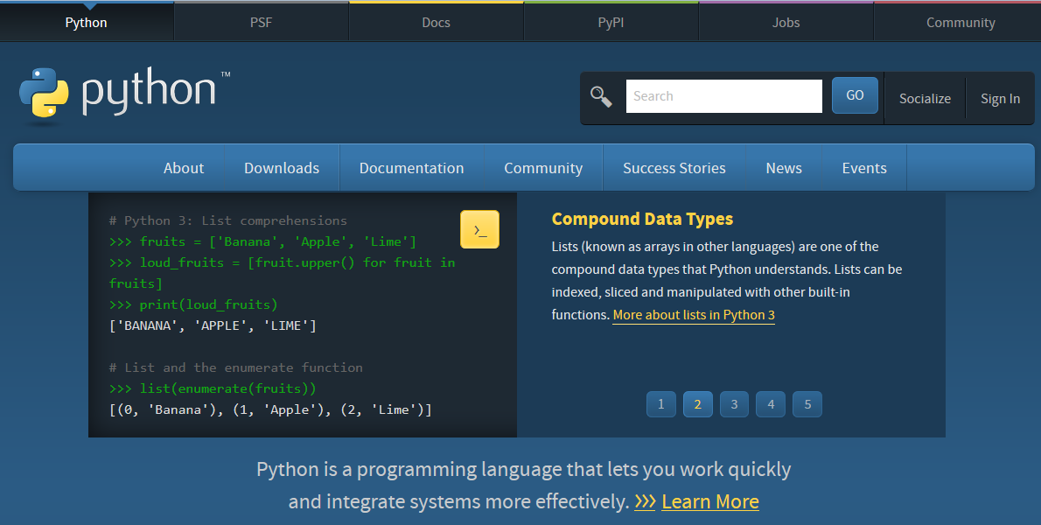

- Installing Python

- Download Python version 3.7 from www.python.org . Do check that you have downloaded the version for Windows. Save the file onto your desktop.

Note: installation is similar across all operating systems.

- Run the program file that you have downloaded.

- Install for all users.

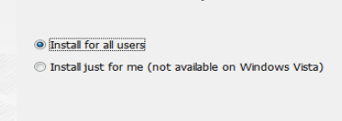

- It is a good idea to accept the defaults and install Python on the “C:\Python36” drive.

- It is also a good idea to “add python.exe to Path”.

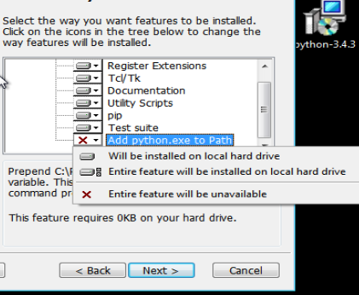

- Installation will take place for a few minutes.

- Installation is completed when you see this message.

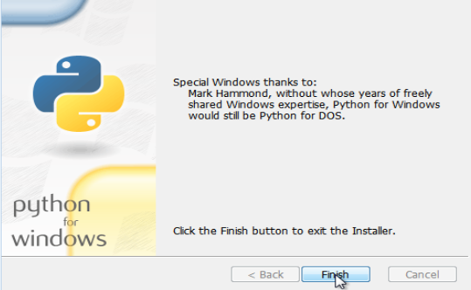

- Using IDLE with Python

We will be using IDLE (Integrated DeveLopment Environment) as our programming environment. IDLE is bundled with Python and is installed as part of the Python installation. You can find IDLE in the programs folder.

When you launched IDLE, you should see a screen like:

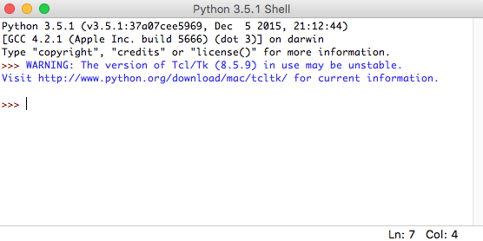

- Writing Hello World

It is customary for all programmers to write the “Hello World” program. It is also to see if your Python installation is working correctly. Type in the following expression in IDLE and press the “return/enter” key. Write down the output given by IDLE.

Input | Output
print ("Hello World!")

Note: do alert your tutor if strange results occur.

